Child’s Name: |  | Date of Birth / CHI if known
Address: |  | GP Name/ Surgery:
Postcode: |  | GP Tel Number
Tel number:  Mobile: |  | May we contact your GP if required? | Yes No
May we leave a message? | Yes No | If you require and Interpreter – which language

Please give a brief description of why you would like a children’s physiotherapy assessment and how the problem is affecting your child?

Please tick your answers below:
Have you consulted your GP about this problem? | Yes | No
Are they in pain? | Yes | No
Do you think they are getting worse? | Yes | No
How long have they had this problem? | Days | Weeks | Months | Years
Are they off school because of this problem? | Yes | No | n/a
Is pain disturbing their sleep? | Yes | No | n/a
Are they able to participate in normal activities? | Yes | No
Have they had this before? | Yes | No
Have they had physiotherapy for this or for any other problem before? | Yes | No
Do you think your child has delay in their movement development? | Yes | No

Please tell us of any existing medical conditions/ health problems they have and any medications they are taking:

Parental Consent Obtained: |  | Yes |  | No
Person completing form: (print) |  |  | Relationship to child:
Signature: |  |  | Date:
Full Address with Postcode: |  |  | Telephone number:
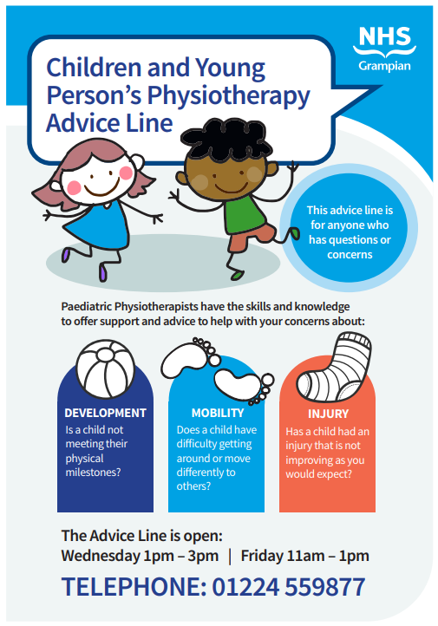
Who can request for assistance from the Children’s Physiotherapy Department?
Anyone who has a concern about a child/young person under the age of 16 may submit a request for assistance form for Physiotherapy. Children and young people up to age 16 may also self-refer.

How can Physiotherapy help?
Physiotherapy is helpful for a number of musculoskeletal problems like low back pain, recent injuries such as strains and sprains, or joint and muscular pain. It is important you give us as much information about your concerns and how it is affecting your child. Lots of children and young people can have aches and pains which is a normal part of growing up, but if pain is persistent i.e. not going away for longer than 4 weeks, or keeping you awake at night then a physiotherapy assessment may be useful.

I’ve completed this form, what happens next?
A Children’s Physiotherapist will process your form. We will then contact you to discuss the best course of action for your child. This may be to ask for more details, offer some advice, to make plans for an appointment or to signpost your child to another service based on the information you have supplied. Depending on the nature of your child’s condition they may be placed on a waiting list. If you have any concerns or their condition worsens you should make an appointment with your GP or call the dedicated Paediatric Physiotherapy Advice Line (see image above for more details).
What can I do to help myself in the meantime?
Painkillers? - Over the counter painkillers can be helpful. A pharmacist will be able to advise you on the appropriate medication. If symptoms worsen you may need to see your child’s GP.
Hot or Cold? - You can put ice on a recent sprain/ strain. Use a pack of frozen peas wrapped in a damp towel for 10 minutes. Older injuries may respond better to heat and using a hot water bottle wrapped in a towel for 10 minutes reduces pain. Be aware that both hot and cold treatments can burn and that you need to check (every 5 minutes) that skin is not becoming very red or blotchy. If this happens, stop.
Rest? - Research shows that that resting for longer than 48 hours can sometimes cause stiffness and prolong pain. After this period it will be useful to “get moving” gently by reducing your usual activities and then building them up slowly again as pain allows.

